**Project 27：Temperature Measurement**

1. **Introduction**

LM35 is a commonly used and easy-to-use temperature sensor. It does not require other hardware, only needs an analog port. The difficulty lies in compiling the code and converting the analog values to Celsius temperature. In this project, we use a temperature sensor and 3 LEDs to make a temperature tester. When the temperature sensor touches objects with different temperature, the LED will show different colors.

1. **Components Required**

|  |  |  |  |  |  |  |
| --- | --- | --- | --- | --- | --- | --- |
| 17a6d7f241a04d4e932cb06b758197c4 | | _DSC2552 | | 3 |  | |
| Raspberry Pi Pico\*1 | | Raspberry Pi Pico Expansion Board\*1 | | LM35 Temperature Sensor\*1 | USB Cable\*1 | |
|  | 红 (4) | y | 绿 (5) | 杜邦线-1 |  |  |
| 220Ω Resistor\*3 | Red LED\*1 | Yellow LED\*1 | Green LED\*1 | F-F Dupont Wires | Breadboard\*1 | Jumper Wires |

1. **Component Knowledge**

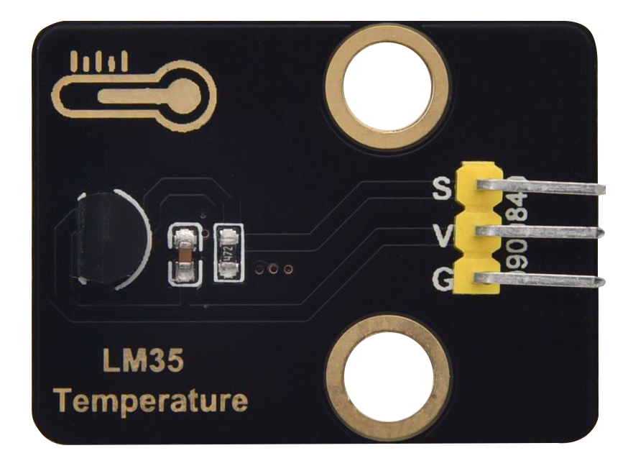

**Working principle of LM35 temperature sensor:** LM35 is a widely used temperature sensor with many different package types. At room temperature, it can achieve the accuracy of 1/4°C without additional calibration processing. LM35 temperature sensor can produce different voltage by different temperature.When the temperature is 0 ℃, it outputs 0V. If increasing 1 ℃, the output voltage will increase 10mv.

The output temperature is 0℃ to 100℃, the conversion formula is as follows.

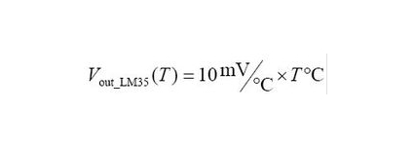

1. **Read the Temperature Value**

We first use a simple code to read the value of the temperature sensor, print it in the serial monitor. The wiring diagram is shown below.

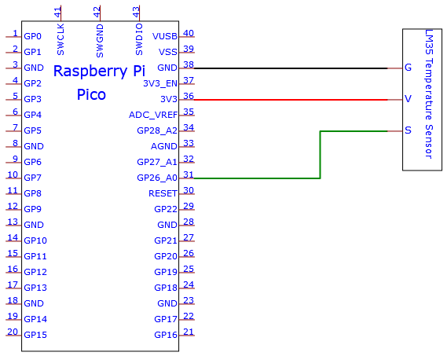

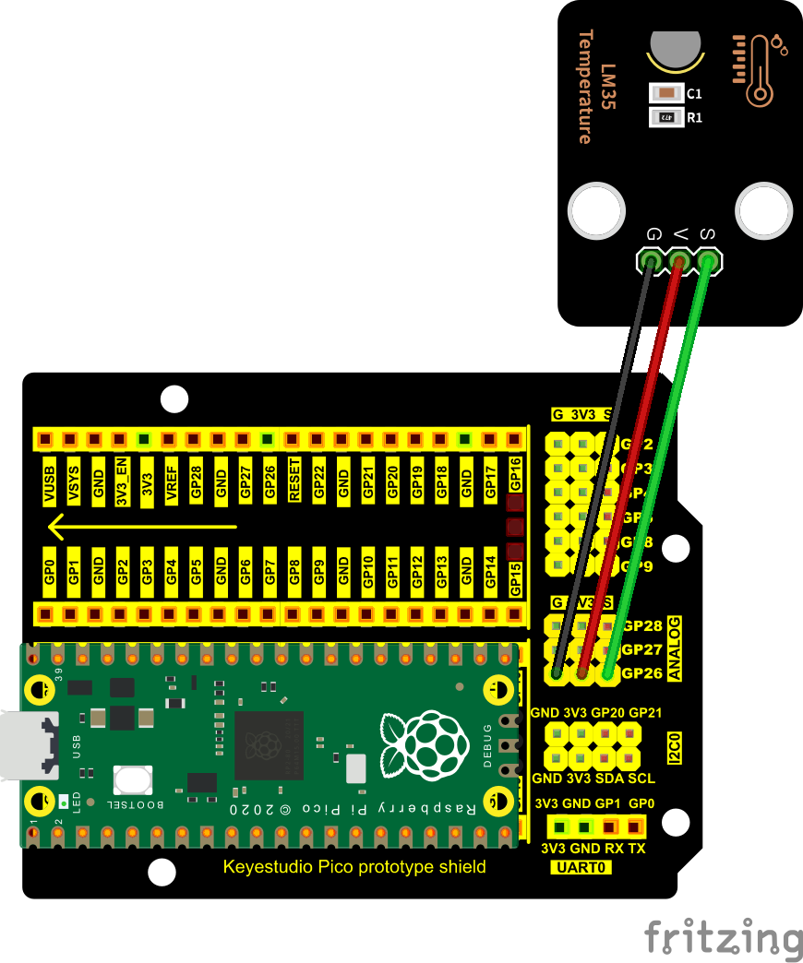

LM35 output is given to analog pin GP26 of the pico board. This analog voltage is converted to its digital form and processed to get the temperature reading.

You can open the code we provide:

Go to the folder KS3020 Keyestudio Raspberry Pi Pico Learning Kit Ultimate Edition\2. Windows System\2. C\_Tutorial\2. Projects\Project 27：Temperature Measurement\Project\_27.1\_Read\_LM35\_Temperature\_Value

|  |
| --- |
| //\*\*\*\*\*\*\*\*\*\*\*\*\*\*\*\*\*\*\*\*\*\*\*\*\*\*\*\*\*\*\*\*\*\*\*\*\*\*\*\*\*\*\*\*\*\*\*\*\*\*\*\*\*\*\*\*\*\*\*\*\*\*\*\*\*\*\*\*\*\*\*\*\*\*\*\*\*\*\*\*\*\*  /\*  \* Filename : Read LM35 Temperature Value  \* Description : ADC value is converted to LM35 temperature value  \* Auther : http//www.keyestudio.com  \*/  #define PIN\_ANALOG\_IN 26 //the pin of the Sound Sensor  void setup() {  Serial.begin(115200);  }  //In loop() function, analogRead is called to get the ADC value of ADC0 and assign it to adcVal.  //Calculate the measured voltage value,Celsius and Fahrenheit valuesthrough the formula,  //and print these data through the serial port monitor.  void loop() {  int adcVal = analogRead(PIN\_ANALOG\_IN);  double voltage = adcVal / 1023.0 \* 3.3;  float temperatureC = (voltage \* 1000.0) / 10.0 ;  float temperatureF = (temperatureC \* 1.8) + 32.0;  Serial.print("ADC Value: " + String(adcVal));  Serial.print("---Voltage Value: " + String(voltage) + "V");  Serial.print("---temperatureC: " + String(temperatureC) + "℃");  Serial.println("---temperatureF: " + String(temperatureF) + "F");  delay(500);  }  //\*\*\*\*\*\*\*\*\*\*\*\*\*\*\*\*\*\*\*\*\*\*\*\*\*\*\*\*\*\*\*\*\*\*\*\*\*\*\*\*\*\*\*\*\*\*\*\*\*\*\*\*\*\*\*\*\*\*\*\*\*\*\*\*\*\*\*\*\*\*\*\*\*\*\*\*\*\*\*\*\*\* |

Before uploading Test Code to Raspberry Pi Pico, please check the configuration of Arduino IDE.

Click "Tools" to confirm that the board type and ports.

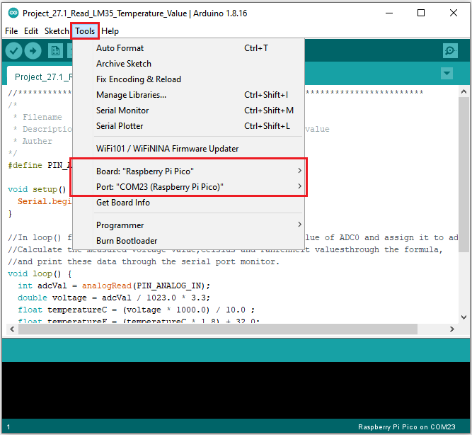

Click  to upload the test code to the Raspberry Pi Pico board

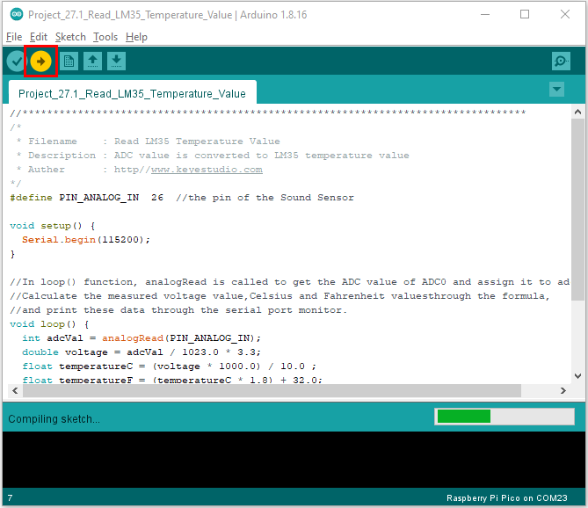

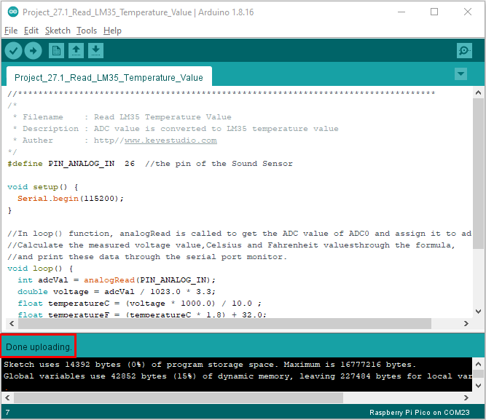

Upload the code to the pico board, power up with a USB cable and open the serial monitor and set baud rate to 115200. The serial monitor will show the temperature value.

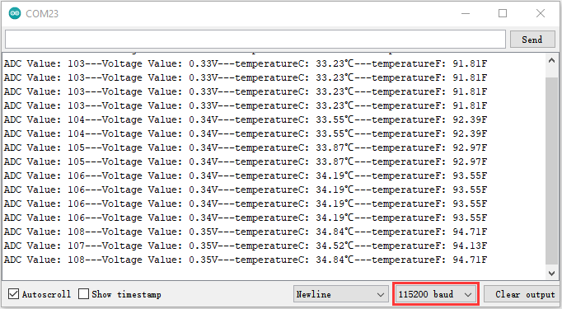

1. **Circuit Diagram and Wiring Diagram**

Now we use a LM35 temperature sensor and three LED lights to do a temperature test. When the LM35 temperature sensor senses different temperatures, different LED lights will light up. Follow the diagram below for wiring.

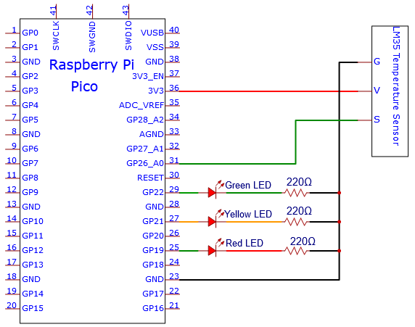

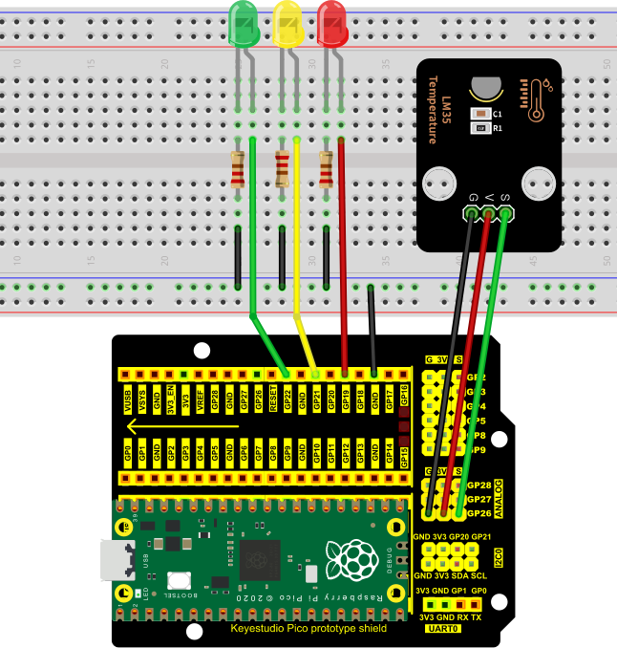

1. **Test Code：**

Note：The value of“temperature F”in the code can be adjusted appropriately according to the local temperature value.

You can open the code we provide:

Go to the folder KS3020 Keyestudio Raspberry Pi Pico Learning Kit Ultimate Edition\2. Windows System\2. C\_Tutorial\2. Projects\Project 27：Temperature Measurement\Project\_27.2\_Temperature\_Measurement.

|  |
| --- |
| //\*\*\*\*\*\*\*\*\*\*\*\*\*\*\*\*\*\*\*\*\*\*\*\*\*\*\*\*\*\*\*\*\*\*\*\*\*\*\*\*\*\*\*\*\*\*\*\*\*\*\*\*\*\*\*\*\*\*\*\*\*\*\*\*\*\*\*\*\*\*\*\*\*\*\*\*\*\*\*\*\*\*  /\*  \* Filename : Temperature Measurement  \* Description : Different leds light up when the LM35 senses different temperatures  \* Auther : http//www.keyestudio.com  \*/  #define PIN\_ADC2 26 //the pin of the Sound Sensor  #define PIN\_GREENLED 22 //the pin of the Green led  #define PIN\_YELLOWLED 21 //the pin of the Yellow led  #define PIN\_REDLED 19 //the pin of the Red led  void setup() {  Serial.begin(115200);  pinMode(PIN\_GREENLED, OUTPUT); //set PIN\_GREENLED to OUTPUT  pinMode(PIN\_YELLOWLED, OUTPUT);//set PIN\_YELLOWLED to OUTPUT  pinMode(PIN\_REDLED, OUTPUT);//set PIN\_REDLED to OUTPUT  pinMode(PIN\_ADC2, INPUT);//set PIN\_ADC2 to INPUT  }  void loop() {  int adcVal = analogRead(PIN\_ADC2);  double voltage = adcVal / 1023.0 \* 3.3;  float temperatureC = (voltage \* 1000.0) / 10.0 ;  float temperatureF = (temperatureC \* 1.8) + 32.0;  Serial.print("ADC Value: " + String(adcVal));  Serial.print("---Voltage Value: " + String(voltage) + "V");  Serial.print("---temperatureC: " + String(temperatureC) + "℃");  Serial.println("---temperatureF: " + String(temperatureF) + "F");  if (temperatureF >= 95) {  digitalWrite(PIN\_GREENLED, LOW);  digitalWrite(PIN\_YELLOWLED, LOW);  digitalWrite(PIN\_REDLED, HIGH);  }  else if (temperatureF >= 90 && temperatureF < 95) {  digitalWrite(PIN\_GREENLED, LOW);  digitalWrite(PIN\_YELLOWLED, HIGH);  digitalWrite(PIN\_REDLED, LOW);  }  else {  digitalWrite(PIN\_GREENLED, HIGH);  digitalWrite(PIN\_YELLOWLED, LOW);  digitalWrite(PIN\_REDLED, LOW);  }  delay(500);  }  //\*\*\*\*\*\*\*\*\*\*\*\*\*\*\*\*\*\*\*\*\*\*\*\*\*\*\*\*\*\*\*\*\*\*\*\*\*\*\*\*\*\*\*\*\*\*\*\*\*\*\*\*\*\*\*\*\*\*\*\*\*\*\*\*\*\*\*\*\*\*\*\*\*\*\*\*\*\*\*\*\*\* |

Before uploading Test Code to Raspberry Pi Pico, please check the configuration of Arduino IDE.

Click "Tools" to confirm that the board type and ports.

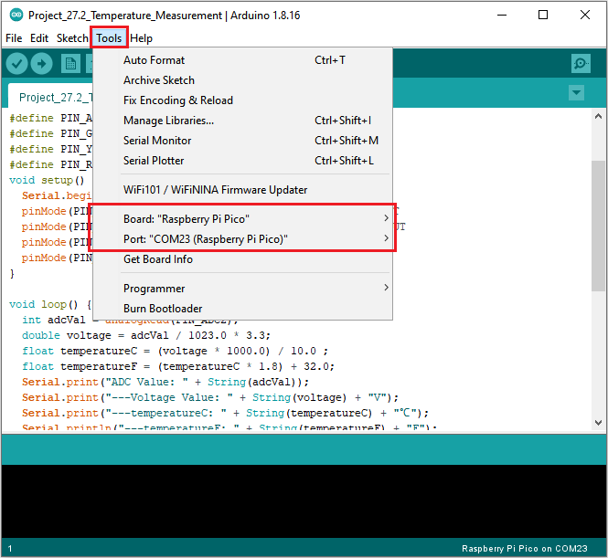

Click  to upload the test code to the Raspberry Pi Pico board

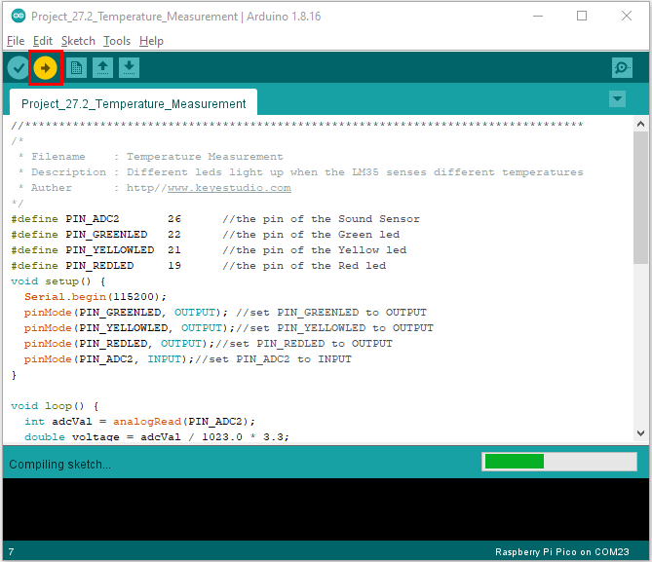

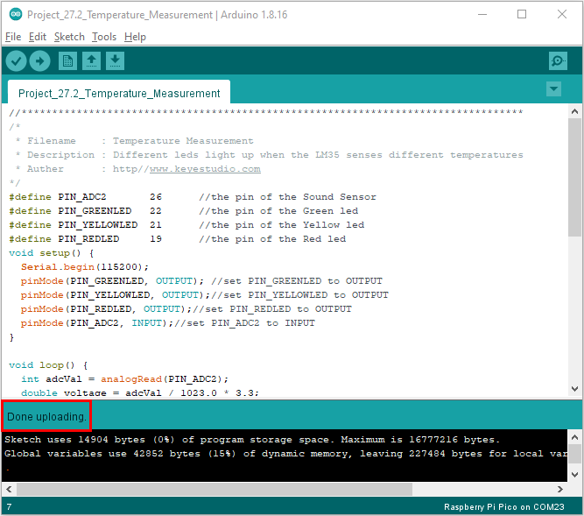

**Test Result**

The monitor displays the current temperature value. When the LM35 temperature sensor senses different temperatures, different LED lights will light up.